Experiment 10: Heuristic Search

Aim:
To implement Heuristic Search using the Greedy Best-First Search algorithm, which selects the next node to explore based on the heuristic value estimating the distance to the goal, thereby improving search efficiency.

Algorithm:
Greedy Best-First Search Algorithm
- Start with the initial node and place it in a priority queue.
- Assign each node a heuristic value ℎ(𝑛)— an estimate of the cost to reach the goal.
- Select the node with the lowest heuristic value from the queue.
- Expand that node and generate its successors.
- For each successor:
  - If it has not been visited, add it to the queue with its heuristic value.
- Repeat steps 3–5 until the goal node is selected.
- Return the path from start to goal.

Source Code:
import heapq
def greedy_best_first_search(graph, start, goal, heuristic): # Priority queue based on heuristic value
frontier = []
heapq.heappush(frontier, (heuristic[start], [start])) visited = set()
while frontier:
h_val, path = heapq.heappop(frontier)

node = path[-1] if node == goal: return path
if node not in visited: visited.add(node)
for neighbor in graph.get(node, []): if neighbor not in visited:
new_path = path + [neighbor]
heapq.heappush(frontier, (heuristic[neighbor], new_path)) return None
# Example graph graph = {
'A': ['B', 'C'],
'B': ['D', 'E'],
'C': ['F'],
'D': [],
'E': ['G'],
'F': [],
'G': []
}
# Heuristic values (estimated distance to goal) heuristic = {
'A': 7,
'B': 6,
'C': 4,
'D': 5,
'E': 2,
'F': 3,
'G': 0

}
path = greedy_best_first_search(graph, 'A', 'G', heuristic) print("Path found using Heuristic Search:", path)

Flowchart:

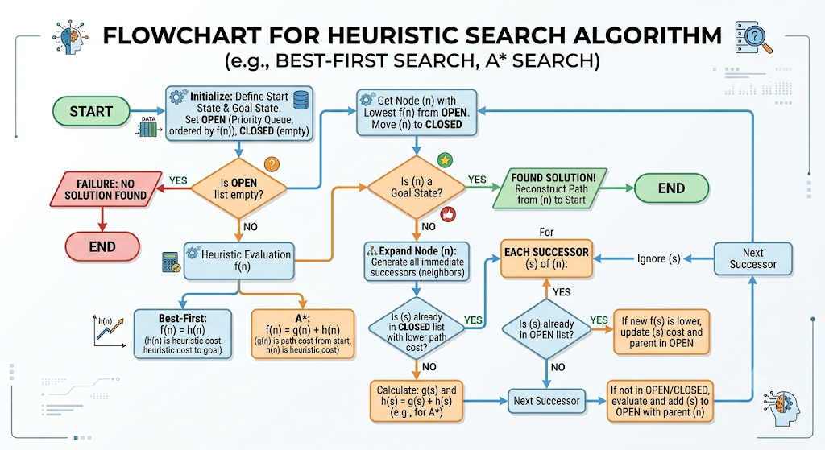

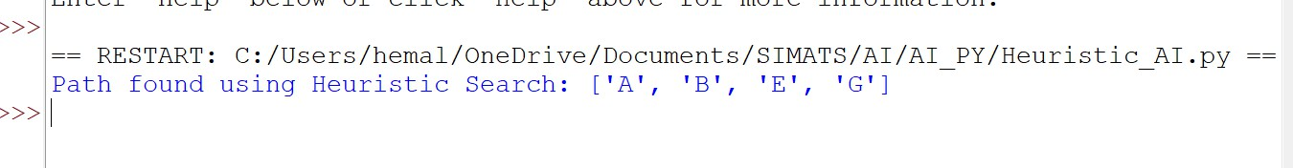
Output:

Result:
The Heuristic Search algorithm successfully finds the goal node G starting from A, guided by heuristic values that estimate proximity to the goal. The final path obtained is:
A → B → E → G
This confirms that heuristic search efficiently directs exploration toward the goal, reducing unnecessary node expansions compared to uninformed search methods.

